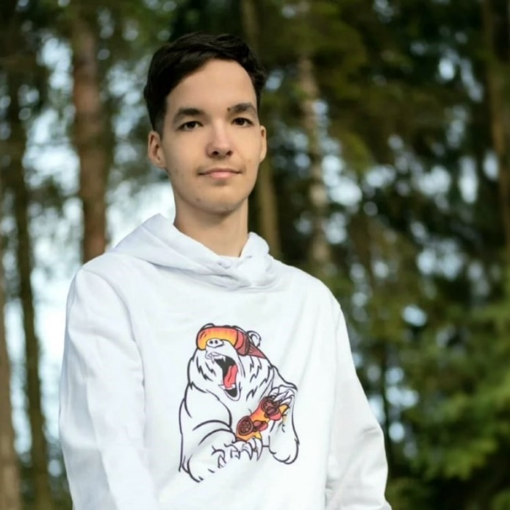

Egor Tomashin`s project portfolio

Unity Game Developer (Mobile, AR&VR)

Game Designer

Content

FIRGAMESUS (Egor Tomashin) 3

Mathematical game «Find Pi» 3

VR Games Collection 3

Holiday Calendar «Today`s Reason To Drink» 4

Open-Source Projects 4

Moscow Polytechnic University 4

AR 09.03.02 4

ARtales 4

Regiment AR — 9 may 2020 5

Magic Quick 5

Magic Kids 5

VKSpace 6

Earworm Studio 6

Farm House Story Match-3 6

# [FIRGAMESUS (Egor Tomashin)](https://firgamesus.ru/)

## Mathematical game «Find Pi»

 "Find Pi" is a mathematical game that allows you to acquire the skills of quickly and accurately determining the angle in radians.

You are given a single circle with a point on it and 4 possible answers. The dot shows angles that are multiples of 30 and 45 degrees in both positive and negative directions. The task is to determine the angle in radians and choose the correct answer. Answered correctly-continue, and if you failed – alas, start again.

This is an educational game that is suitable not only for high school students in the course of trigonometry, but also for everyone to develop fast counting.

|  |  |
| --- | --- |
| Team | [Egor Tomashin](https://vk.com/tomashined) (idea and implementation),  [Varvara Rakova](https://vk.com/vr_rk) (design) |
| Platforms | [Google Play (Android)](https://play.google.com/store/apps/details?id=com.FIBEG.FindPi) – 11.02.2019 (UPD 22.08.2020) |

## VR Games Collection

 VR Games Collection is a small collection of several mobile mini-games in virtual reality. You just need to have a regular cardboard Google Cardboard in order to spend time with pleasure. All control in the game is carried out by looking - that is, you just need to look at the desired object (point at it) to take the action that is required for it.

|  |  |
| --- | --- |
| Team | [Egor Tomashin](https://vk.com/tomashined) (idea and implementation) |
| Platforms | [Google Play (Android)](https://play.google.com/store/apps/details?id=com.FirsusGames.VRGamesCollection) – 12.11.2019 |

The first experience of working with virtual reality using Google VR (Google Cardboard), it is planned to resume development for exhibiting as a diploma project.

## Holiday Calendar «Today`s Reason To Drink»

 Today`s Reason To Drink is a calendar application that gives out a huge number of different holidays for any day, for which you can drink. Let's celebrate every day together!

|  |  |
| --- | --- |
| Team | [Egor Tomashin](https://vk.com/tomashined) (idea and implementation) |
| Platforms | [Google Play (Android)](https://play.google.com/store/apps/details?id=com.FG.TRTD) – 21.08.2019 (UPD 31.08.2020) |

## Open-Source Projects

Various unfinished projects and solutions to test tasks, etc., can be viewed in a separate GitHub repository [at the link](https://github.com/tomashinopensource).

# Moscow Polytechnic University

## AR 09.03.02

 AR 09.03.02 is an AR app to the brochure on the direction 09.03.02 "Information Systems and Technologies" of the Moscow Polytechnic University. You need to point the camera in the app to the corresponding page in the brochure and you can view the video in augmented reality. At this moment, a test version of the application has been posted, working with the attached images on Google Play.

|  |  |
| --- | --- |
| Team | Dmitry Arsentiev (idea),  [Egor Tomashin](https://vk.com/tomashined) (implementation) |
| Platforms | [Google Play (Android)](https://play.google.com/store/apps/details?id=com.FG.AR090302) – 7.05.2019 (stopped) |

It is the first experience of working with AR (augmented reality) using conventional tag technology to play video over an image.

## ARtales

The world of fairy tales breaks into our universe in a completely new way, thanks to the power of augmented reality. Try our new mobile app, which will help you to revive the characters of folk tales that are already familiar to you! The app works in conjunction with a specially designed book.

|  |  |
| --- | --- |
| Team | [Ilya Kolgushkin](https://vk.com/eliamatlin) (idea and implementation),  [Egor Tomashin](https://vk.com/tomashined) (release to Google Play) |
| Platforms | [Google Play (Android)](https://play.google.com/store/apps/details?id=com.FG.AR090302) – 7.05.2019 (stopped) |

## Regiment AR — 9 may 2020

"Regiment AR — 9 may 2020" is an application with augmented reality technologies, dedicated to people who participated in the WWII. Thanks to it, you can feel like a part of the All-Russian march in honor of the great victory. You can find more than 25 thousand data on WWII veterans, and look at almost 100 of them at once. To work correctly, you need support for ARCore technology on your Android device.

|  |  |
| --- | --- |
| Team | Oleg Kuznetsov (idea),  Dmitry Arsentiev (curator),  [Alexey Kolodochkin](https://vk.com/a.kolodochkin) (curator),  [Egor Tomashin](https://vk.com/tomashined) (реализация),  [Ivan Arzamazov](https://vk.com/alevideintra) (parsing data to the database),  [Varvara Rakova](https://vk.com/vr_rk) (design) |
| Platforms | [Google Play (Android)](https://play.google.com/store/apps/details?id=com.FIRGAMESUS.PolkAR) – 06.05.2020 (stopped) |

# [Magic Quick](https://magicquick.me/ru)

## Magic Kids

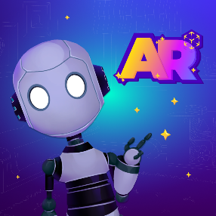Magic Kids: Fun AR Learning - Now your kids have the power to create their own educational experiences anywhere with your iPhone or iPad! Magic Kids will help your child learn through immersive, interactive, hands-on lessons using NEW augmented reality and machine learning technology.

|  |  |
| --- | --- |
| My work | Development of a 3D version of the "Logic and Forms" block |
| Platforms | Website - [App Store (iOS)](https://apps.apple.com/us/app/magic-kids-ar-learning-games/id1516516502) – June 2020 |

## VKSpace

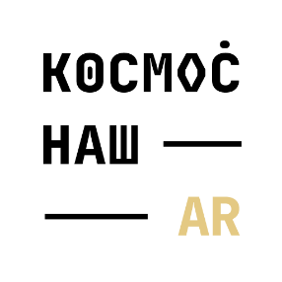VKSpace is a fascinating mobile application using augmented reality technology. The application allows you to get acquainted in an interactive format with the history of the Soviet-Russian cosmonautics, to be on Mars, to save the Earth from an impending meteorite and even go on a trip to the far corners of the galaxy!

|  |  |
| --- | --- |
| My work | Development of the first and third games of the second block |
| Platforms | [VKontakte](https://vk.com/app7583583_81122752) (Russian social network) – November 2020  [Google Play (Android)](https://play.google.com/store/apps/details?id=com.MagicQuick.VKSpace&hl=ru) – November 2020  [App Store (iOS)](https://apps.apple.com/ru/app/%D0%BA%D0%BE%D1%81%D0%BC%D0%BE%D1%81-%D0%BD%D0%B0%D1%88/id1536197773) – November 2020 |

# [Earworm Studio](http://earworm.studio/)

## Farm House Story Match-3

The new game Farm Stories combines two popular game genres: 3 in a row and farm. A bright and exciting game that you can play with children. 5 locations, more than 100 levels of varying difficulty. Travel to the farm to harvest crops of delicious and healthy vegetables. Collect points and stars. Complete all tasks to complete the level. Get a variety of items and bonuses that will help you complete the levels faster and score more points.

|  |  |
| --- | --- |
| My work | Redesign of the plugin source code, adding new mechanics and elements, release for Android and WebGL. |
| Platforms | [Google Play (Android)](https://play.google.com/store/apps/details?id=com.earworm.farmhousestory) – October 2020  [Odnoklassniki](https://ok.ru/game/farmhousestory) – October 2020  VKontakte – November 2020 |